**Roll no:: 412084**

**Prn No: 2019033800126574**

**Name:: Yagnik Mojidra**

**:Assignment-2:**

**Github::**

**\*\*Numbers in C#\*\***

**Code:::**

using System;

class Program

{

public static void Main(string[] args)

{

int a = 10, b = 5, c = 15;

double x = 5, y = 10, z = 15;

// this is first part numbers in c#

add(a, b);

sub(a, b);

mul(a, b);

div(a, b);

complex1(a,b,c);

complex2(a,b,c);

findMinMax();

doubleArith(x,y,z);

doubleMinMax();

roundingError();

decimalMinMax();

decimalDouble();

areaOfCircle(a);

// second part branching and loops part

// branching(a, b);

// ifElse1(a, b);

// compare1(a, b, c);

// compare2(a, b, c);

// whileLoop();

// doWhileLoop();

// forLoop();

// nestedLoop();

// isDivisibleBy3();

}

// first part numbers in c#

public static void add(int m, int n)

{

int p = m + n;

Console.WriteLine("The Addition is :" + p);

}

public static void sub(int m, int n)

{

int p = m - n;

Console.WriteLine("The Substraction is :" + p);

}

public static void mul(int m, int n)

{

int p = m * n;

Console.WriteLine("The Multipication is :" + p);

}

public static void div(int m, int n)

{

int p = m / n;

Console.WriteLine("The Division is :" + p);

}

public static void complex1(int m, int n, int h)

{

int p = m + n * h;

Console.WriteLine("The result is :" + p);

}

public static void complex2(int m, int n, int h)

{

int p = (m + n) / h;

int q = (m + n) % h;

Console.WriteLine("The quotient :" + p);

Console.WriteLine("The reminder is :" + q);

}

public static void findMinMax()

{

int p = int.MaxValue;

int q = int.MinValue;

Console.WriteLine("The integer minValue is :" + q);

Console.WriteLine("The integer maxValue is :" + p);

}

public static void doubleArith(double m, double n, double h)

{

double p = (m + n) / h;

Console.WriteLine("The result of this expression (m+n)/h :" + p);

}

public static void doubleMinMax()

{

double p = double.MaxValue;

double q = double.MinValue;

Console.WriteLine("The double minValue is :" + q);

Console.WriteLine("The double maxValue is :" + p);

}

public static void roundingError()

{

double t = 1.0 / 3.0;

Console.WriteLine("Rounding error in double is:" + t);

}

public static void decimalMinMax()

{

decimal p = decimal.MaxValue;

decimal q = decimal.MinValue;

Console.WriteLine("The decimal minValue is :" + q);

Console.WriteLine("The decimal maxValue is :" + p);

}

public static void decimalDouble()

{

double p = 1.0;

double q = 3.0;

Console.WriteLine("The value of (p/q) :" + (p / q));

decimal c = 1.0M;

decimal d = 3.0M;

Console.WriteLine("The decimal value of (p/q) :" + (c / d));

}

public static void areaOfCircle(int a)

{

double area = Math.PI * a * a;

Console.WriteLine("The area of Circle is: " + area);

}

// second part (branches and Loops)

// public static void branching(int m, int n)

// {

// if (m + n > 10)

// {

// Console.WriteLine("The Answer of a+b Is greater than 10");

// }

// }

// public static void ifElse1(int m, int n)

// {

// if (m + n > 10)

// {

// Console.WriteLine("The Answer of a+b Is greater than 10");

// }

// else

// {

// Console.WriteLine("The Answer of a+b Is not greater than 10");

// }

// }

// public static void compare1(int m, int n, int p)

// {

// if ((m + n + p > 10) && (m == n))

// {

// Console.WriteLine("The Answer of a+b+c Is greater than 10");

// Console.WriteLine("And the first number is equal to the second number");

// }

// else

// {

// Console.WriteLine("The Answer of a+b Is not greater than 10");

// Console.WriteLine("And the first number is not equal to the second number");

// }

// }

// public static void compare2(int m, int n, int p)

// {

// if ((m + n + p > 10) || (m == n))

// {

// Console.WriteLine("The Answer of a+b+c Is greater than 10");

// Console.WriteLine("Or the first number is equal to the second number");

// }

// else

// {

// Console.WriteLine("The Answer of a+b Is not greater than 10");

// Console.WriteLine("Or the first number is not equal to the second number");

// }

// }

// public static void whileLoop()

// {

// int counter = 0;

// while (counter < 10)

// {

// Console.WriteLine("The Counter round is :" + counter);

// counter++;

// }

// }

// public static void doWhileLoop()

// {

// int counter = 0;

// do

// {

// Console.WriteLine("The Counter round is :" + counter);

// counter++;

// } while (counter < 10);

// }

// public static void forLoop()

// {

// for (int i = 0; i < 10; i++)

// {

// Console.WriteLine("Hello world !That is :" + i + "times!");

// }

// }

// public static void nestedLoop()

// {

// for (int row = 1; row < 6; row++)

// {

// for (char col = 'a'; col <'i';col++){

// Console.WriteLine($"The Cell is suggested that ({row},{col})");

// }

// }

// }

// public static void isDivisibleBy3(){

// int sum = 0;

// for (int number= 0; number<18;number++){

// if(number%3==0){

// sum+=number;

// }

// }

// Console.WriteLine($"The sum is: {sum} ");

// }

}

**Output:**

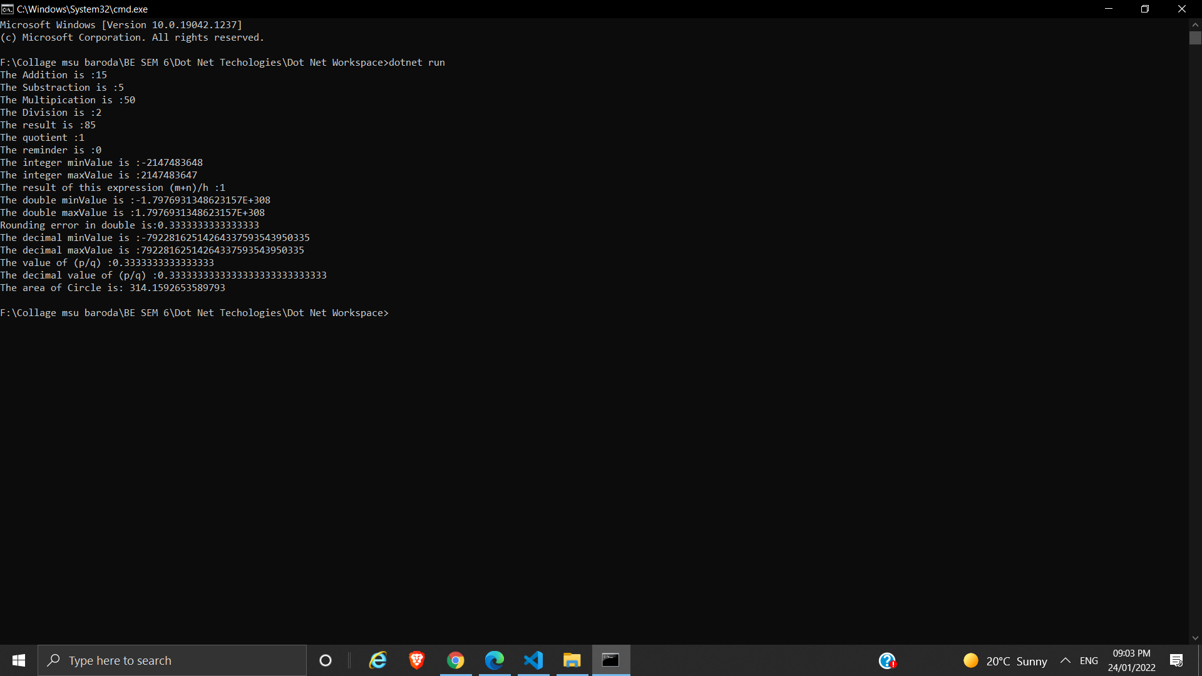

**\*\*\*Branching and Loops\*\*\***

**Code:::**

using System;

class Program

{

public static void Main(string[] args)

{

int a = 10, b = 5, c = 15;

// double x = 5, y = 10, z = 15;

// this is first part numbers in c#

// add(a, b);

// sub(a, b);

// mul(a, b);

// div(a, b);

// complex1(a,b,c);

// complex2(a,b,c);

// findMinMax();

// doubleArith(x,y,z);

// doubleMinMax();

// roundingError();

// decimalMinMax();

// decimalDouble();

// areaOfCircle(a);

// second part branching and loops part

branching(a, b);

ifElse1(a, b);

compare1(a, b, c);

compare2(a, b, c);

whileLoop();

doWhileLoop();

forLoop();

nestedLoop();

isDivisibleBy3();

}

// first part numbers in c#

// public static void add(int m, int n)

// {

// int p = m + n;

// Console.WriteLine("The Addition is :" + p);

// }

// public static void sub(int m, int n)

// {

// int p = m - n;

// Console.WriteLine("The Substraction is :" + p);

// }

// public static void mul(int m, int n)

// {

// int p = m * n;

// Console.WriteLine("The Multipication is :" + p);

// }

// public static void div(int m, int n)

// {

// int p = m / n;

// Console.WriteLine("The Division is :" + p);

// }

// public static void complex1(int m, int n, int h)

// {

// int p = m + n * h;

// Console.WriteLine("The result is :" + p);

// }

// public static void complex2(int m, int n, int h)

// {

// int p = (m + n) / h;

// int q = (m + n) % h;

// Console.WriteLine("The quotient :" + p);

// Console.WriteLine("The reminder is :" + q);

// }

// public static void findMinMax()

// {

// int p = int.MaxValue;

// int q = int.MinValue;

// Console.WriteLine("The integer minValue is :" + q);

// Console.WriteLine("The integer maxValue is :" + p);

// }

// public static void doubleArith(double m, double n, double h)

// {

// double p = (m + n) / h;

// Console.WriteLine("The result of this expression (m+n)/h :" + p);

// }

// public static void doubleMinMax()

// {

// double p = double.MaxValue;

// double q = double.MinValue;

// Console.WriteLine("The double minValue is :" + q);

// Console.WriteLine("The double maxValue is :" + p);

// }

// public static void roundingError()

// {

// double t = 1.0 / 3.0;

// Console.WriteLine("Rounding error in double is:" + t);

// }

// public static void decimalMinMax()

// {

// decimal p = decimal.MaxValue;

// decimal q = decimal.MinValue;

// Console.WriteLine("The decimal minValue is :" + q);

// Console.WriteLine("The decimal maxValue is :" + p);

// }

// public static void decimalDouble()

// {

// double p = 1.0;

// double q = 3.0;

// Console.WriteLine("The value of (p/q) :" + (p / q));

// decimal c = 1.0M;

// decimal d = 3.0M;

// Console.WriteLine("The decimal value of (p/q) :" + (c / d));

// }

// public static void areaOfCircle(int a)

// {

// double area = Math.PI * a * a;

// Console.WriteLine("The area of Circle is: " + area);

// }

// second part (branches and Loops)

public static void branching(int m, int n)

{

if (m + n > 10)

{

Console.WriteLine("The Answer of a+b Is greater than 10");

}

}

public static void ifElse1(int m, int n)

{

if (m + n > 10)

{

Console.WriteLine("The Answer of a+b Is greater than 10");

}

else

{

Console.WriteLine("The Answer of a+b Is not greater than 10");

}

}

public static void compare1(int m, int n, int p)

{

if ((m + n + p > 10) && (m == n))

{

Console.WriteLine("The Answer of a+b+c Is greater than 10");

Console.WriteLine("And the first number is equal to the second number");

}

else

{

Console.WriteLine("The Answer of a+b Is not greater than 10");

Console.WriteLine("And the first number is not equal to the second number");

}

}

public static void compare2(int m, int n, int p)

{

if ((m + n + p > 10) || (m == n))

{

Console.WriteLine("The Answer of a+b+c Is greater than 10");

Console.WriteLine("Or the first number is equal to the second number");

}

else

{

Console.WriteLine("The Answer of a+b Is not greater than 10");

Console.WriteLine("Or the first number is not equal to the second number");

}

}

public static void whileLoop()

{

int counter = 0;

while (counter < 10)

{

Console.WriteLine("The Counter round is :" + counter);

counter++;

}

}

public static void doWhileLoop()

{

int counter = 0;

do

{

Console.WriteLine("The Counter round is :" + counter);

counter++;

} while (counter < 10);

}

public static void forLoop()

{

for (int i = 0; i < 10; i++)

{

Console.WriteLine("Hello world !That is :" + i + "times!");

}

}

public static void nestedLoop()

{

for (int row = 1; row < 6; row++)

{

for (char col = 'a'; col <'i';col++){

Console.WriteLine($"The Cell is suggested that ({row},{col})");

}

}

}

public static void isDivisibleBy3(){

int sum = 0;

for (int number= 0; number<18;number++){

if(number%3==0){

sum+=number;

}

}

Console.WriteLine($"The sum is: {sum} ");

}

}

**Output:::**

